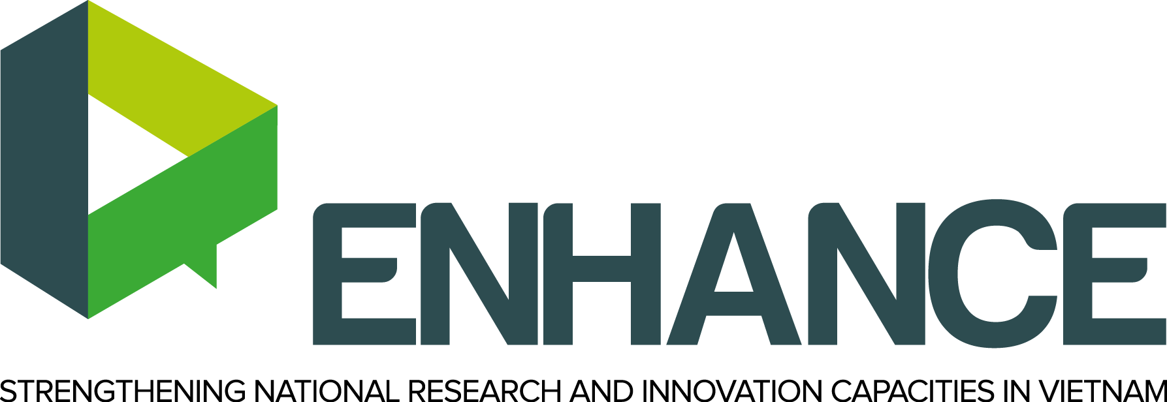

Recommendations towards the improvement of R&I management and implementation in Vietnam

White Paper
D5.1.2
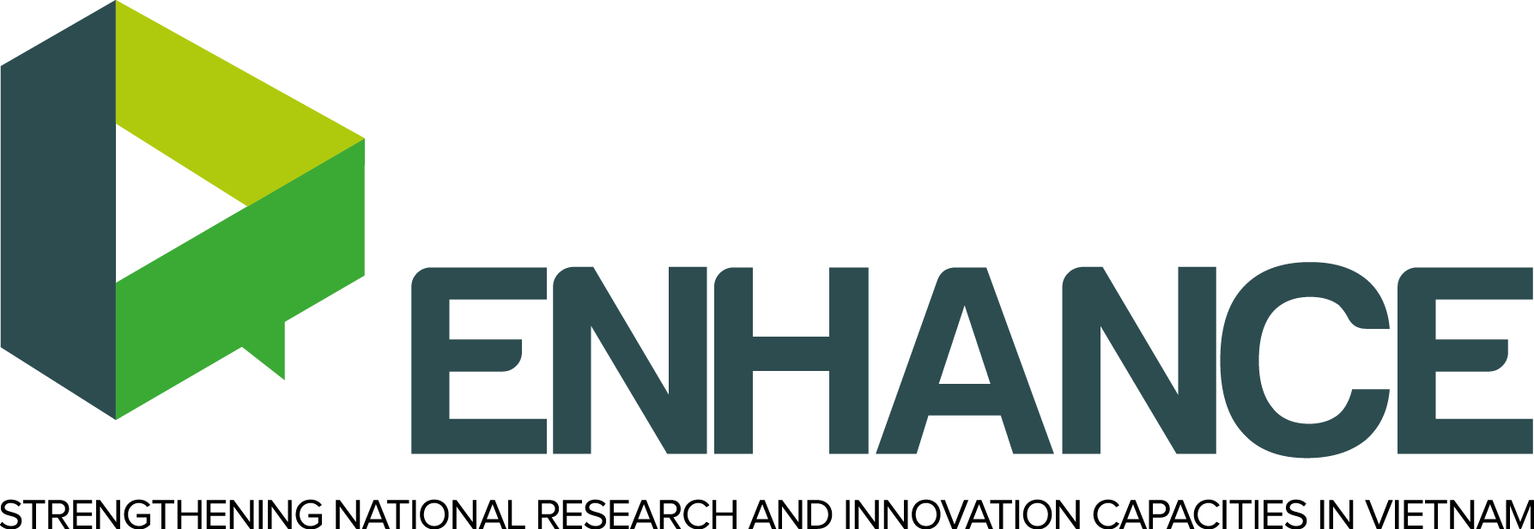

ENHANCE: Strengthening national research and innovation capacities in Vietnam – NATIONAL NEEDS ANALYSIS REPORT

University of Alicante (Spain), Slovak University of Technology in Bratislava (Slovak Republic), Glasgow Caledonian University (Scotland), VNU Hanoi – University of Social Sciences and Humanities (Vietnam), VNU Ho Chi Minh – University of Social Sciences and Humanities (Vietnam), Thai Nguyen University (Vietnam), Hue University of Agriculture and Forestry (Vietnam), An Giang University (Vietnam), Can Tho University (Vietnam), Ministry of Education and Training (Vietnam), Ministry of Science and Technology (Vietnam).

The ENHANCE Project is co-funded by the Erasmus+ Programme of the European Union, with Grant Agreement for an Action with multiple beneficiaries under project reference No. 561749-EPP-1-2015-1-ES-EPPKA2-CBHE-SP.
The Erasmus+ Programme is implemented by Educational, Audio-visual and Culture Executive (EACE) Agency.

The European Commission support for the production of this publication does not constitute any endorsement of the contents which reflects the views only of the authors, and the Commission cannot be held responsible for any use which may be made of the information contained therein.

Table of Contents

List of Abbreviations 5
1. INTRODUCTION 6
1.1. ENHANCE Project 6
1.2. Objectives of the White Paper 7
2. R&I SYSTEM IN VIETNAM HIGHER EDUCATION 9
2.1. Current situation of Vietnamese Higher Education in the Economic Development of Vietnam 9
2.1.1. Challenges for the R&I 9
2.1.2. Transformation needed for R&I 9
2.2. Supports for VIET HEIs in R&I 10
3. GOOD PRACTICES ON THE R&I MANAGEMENT AND IMPLEMENTATION IN VIETNAM 11
4. RECOMMENDATIONS TOWARDS THE IMPROVEMENT OF R&I MANAGEMENT AND IMPLEMENTATION IN VIETNAM 12
4.1. Missions of Higher Education for the Economic Development in Vietnam 12

List of Abbreviations
AGU An Giang University
CTU Can Tho University
E&T Education & Training
EU European Union
HCMUSSH VNU Ho Chi Minh – University of Social Sciences and Humanities
HE Higher Education
HE&RI Higher Education & Research Institutes
HEI Higher Education Institution
HEIs Higher Education Institutions
HUAF Hue University of Agriculture and Forestry
MOET Ministry of Education and Training
MOST Ministry of Science and Technology
NAFOSTED National Foundation for Science & Technology Development
NATIF National Technology Innovation Fund
R&I Research and Innovation
S&T Science and Technology
SMEs Small and Medium Enterprises
STUBA Slovak University of Technology in Bratislava
TNU Thai Nguyen University
USSH VNU Hanoi – University of Social Sciences and Humanities
VNU Vietnam National University
WP5 Work package 5

- INTRODUCTION

  - ENHANCE Project
The ENHANCE Project “Strengthening national research and innovation capacities in Vietnam” is a structural project that will operate at a macro level targeting the Vietnamese HE system (R&I management and implementation). Thanks to a complementary consortium involving 6 of the most relevant Vietnamese HEIs with geographical balance, 3 EU HEIs with huge experience in R&I and international cooperation and the participation of MOET and MOST (HE and S&T authorities). The project is in line with national priorities that give a predominant role to R&I in the mid/long term and its activities have been designed as a response to Vietnam real needs.
The main objective of the ENHANCE project is to strengthen capacities of the Vietnamese higher education system by promoting effective research and innovation management and implementation.
The specific objectives of the ENHANCE Project are:
- To build the human capacities in Research and Innovation Management and Implementation by means of a targeted training programme.
- To strengthen the institutional capacity and enhance national networking by means of setting up a Network of Research and Innovation Offices in Vietnam.
The ENHACE project will be implemented by the following consortium:
Name | Region, Country
Universidad de Alicante (UA) (Coordinator) | Alicante, Spain
Glasgow Caledonian University (GCU) | Glasgow, UK
Slovenská technická univerzita v Bratislave (STUBA) | Bratislava, Slovakia
Thai Nguyen University (TNU) | Thai Nguyen City, Vietnam
VNU Hanoi - University of Social Sciences and Humanities (USSH) | Hanoi, Vietnam
Hue University of Agriculture and Forestry (HUAF) | Hue City, Vietnam
VNU Ho Chi Minh-University of Social Sciences and Humanities (HCMUSSH) | Ho Chi Minh City, Vietnam
An Giang University (AGU) | Long Xuyen City, Vietnam
Can Tho University (CTU) | Can Tho City, Vietnam
Ministry of Education and Training (MOET) | Hanoi, Vietnam
Ministry of Science and Technology - National Institute for Science and Technology Policy and Strategy Studies (MOST – NISTPASS) | Hanoi, Vietnam

The project has been grouped into seven work packages. The main objectives of WP5 “Networking on R&I” were:
- To conduct networking activities of different nature:
- 3 Round Tables targeted on HEIs authorities to foster a discussion on possible improvements and strategy for R&I management at national and institutional levels.
- 3 National Workshops on the most relevant scientific disciplines targeted to the scientific community to foster discussion on R&I implementation improvement at departments and research groups’ levels.
- To produce the ENHANCE White Paper: recommendations toward the improvement of R&I management and implementation in Vietnam.
- To create the ENHANCE Network on R&I Units.

  - Objectives of the White Paper
This White Paper is written under the conclusions withdrawn from the discussion during the 3 Round Tables organized in 3 VIET HEIs. The White Paper will provide recommendations in order to improve the R&I Management in Vietnam, as well as addressing the Management and Implementation of it at R&I level.

- R&I SYSTEM IN VIETNAM HIGHER EDUCATION

  - Current situation of Vietnam Higher Education in the Economic Development of Vietnam
    - Challenges for the R&I
Higher Education Institutions (HEIs) in Vietnam have faced new challenges posed by the globalization throughout the region and the world. Innovation has become a very new aspect in Vietnam, hence generating the needs for VIET HEIs to contribute to the country progress since these HEIs can bring about intelligent and talented students to the workforce and research products for practical usages in Vietnam.
However, another important factor is related to the budget allocated for research in Vietnam. To date, it is acknowledged that many Vietnamese researchers are publishing many researches with such a lower research budget compared to that from European countries, for example. This also reflects the fact that needs of academic/researcher groups have not been well supported financially, and the reason could be due to no concrete measurement for the value added by HEIs in terms of research to the country’s economy.
The seemingly weak academic freedom in Viet HEIs means that topics for research are still much under controlled by the government, therefore academics and researcher communities in Vietnam are not really performing to their fullest. This fact may limit VIET HEIs from the actual capabilities devoted for the general development of the the country, including the economic development. In addition, the issue about Intellectual Property Management in Vietnam is not well performed. This term has appeared to be quite new in Vietnam in recent years; though it may sound familiar to the academic/researcher community in VIET HEIs, they are not really aware of how to adapt the IP issue in their work.
    - Transformation needed for R&I
With the constant transformation of VIET HEIs, their role has become more crucial for the market-oriented society. IP Management has been fostered at national and institutional levels, and there are more and more private enterprises willing to invest in VIET HEIs to collaborate and conduct researches. All these appear to be good sign for VIET HEIs to be encouraged in the contribution the development of the country’s economy.
  - Supports for VIET HEIs in R&I
To foster the research and innovation within the academic/researcher community in VIET HEIs, Vietnamese government has supported in the form of funds. The two most popular types of funds for research and innovation in Vietnam are NAFOSTED (National Foundation for Science and Technology Development) and NATIF (National Technology Innovation Fund). There are 19 other national programmes in Science and Technology available for academic/researcher communities in Vietnam. Moreover, each Ministry has a programme for R&D and regional governments also have their own programmes for R&D.
- GOOD PRACTICES ON THE R&I MANAGEMENT AND IMPLEMENTATION IN VIETNAM

- RECOMMENDATIONS TOWARDS THE IMPROVEMENT OF R&I MANAGEMENT AND IMPLEMENTATION IN VIETNAM

4.1. Missions of Higher Education for the Economic Development in Vietnam

- Strengthening the network among VIET HEIs with the main focus on research.
- Sharing their experience in R&I with one another and collaborate in conducting research in order to gain mutual benefits.
- Collaborating with private sector to put scientific research into practice.
- Working with private sector to allow students work as interns in order to gain work experience.
- Changing and updating the lecturing methods: Making students more active in studying and conducting research.
- Ensuring equality in job competition
- Training students with more soft skills to meet the demands of societies.

