

Management Innovation Development
MIND

Preparation of the MIND training offer for students

SLOVAK UNIVERSITY OF TECHNOLOGY
IN BRATISLAVA

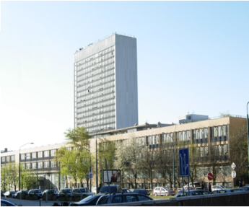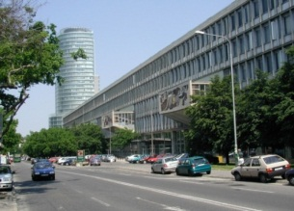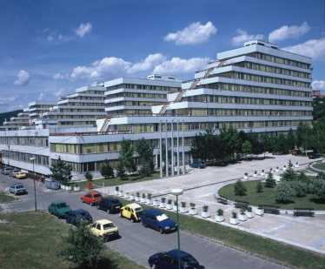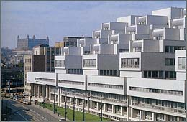
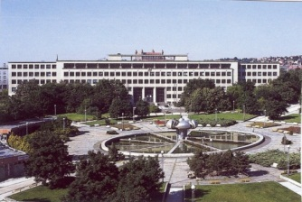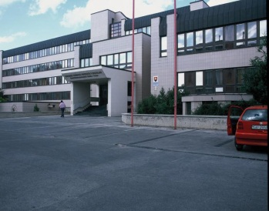

Dates:
September 24 – September 28, 2018

Place of the venue:
● Faculty of Civil Engineering - FofCE
Radlinskeho 11, 2nd floor, C0202, 810 05 Bratislava, Slovak Republic
www.svf.stuba.sk
phone: +42 12 59274221, +42 12 59274587
e-mail: eva.jankovichova@stuba.sk, valeria.lesnakova@stuba.sk

Meeting point: first day, September 24, 2018, 9:30H
Main entrance stairs of Faculty of Civil Engineering STUBA,
Imricha Karvaša street No. 2


GENERAL INSTRUCTIONS

Project Acronym: | MIND
Project full title: | Management – Innovation - Development
Project No: | 561539-EPP-1-2015-1-ES-EPPKA2-CBHE-JP
Funding Scheme: | ERASMUS + KA2
Coordinator: | Universidad Las Palmas de Gran Canaria ULPGC, SPAIN
Project start date: | October 15, 2015
Project duration: | 36 months
Leader of training: | Slovak University of Technology in Bratislava

The Project aims to strengthen the stability of Central Asian universities and to improve the attractiveness of the educational programs. The importance of education for sustainable development, are prioritized in the National Sustainable Development Strategies in the Central Asia (CA) Countries where it states that the quality of education is one of the most reliable indicators of the future development of any nation.

Training for Students in Project MIND is to improve the business skills of students in the design of their business plans.

Participating Organization of the MIND training for the students:

P10 – Tashkent State University of Economics, Uzbekistan - TSUE
P12 – Samarkand Agriculture Institute, Uzbekistan - SAI

Participants¹
NAME | INSTITUTION | COUNTRY
Azizjon BOBOJONOV | Tashkent State University of Economics -  TSUE | Uzbekistan  
Sarvarbek RAKHMATILLAEV | Tashkent State University of Economics -  TSUE
Jakhongir OMONTOSHEV | Tashkent State University of Economics -  TSUE
Oybek FUZAILOV | Tashkent State University of Economics -  TSUE
Khusniddin PARDAEV | Samarkand agricultural institute - SAI
Orzujon FATTOEV | Samarkand agricultural institute - SAI
Bakhodir KHUSHVAKTOV | Samarkand agricultural institute - SAI
Feruz VAFOEV | Samarkand agricultural institute - SAI
Eva JANKOVICHOVÁ | Slovak University of Technology in Bratislava - STUBA | Slovakia  
Valéria LESŇÁKOVÁ | Slovak University of Technology in Bratislava - STUBA
Andrej ŠOLTÉSZ | Slovak University of Technology in Bratislava - STUBA
Richard MATÚŠEK | Slovak University of Technology in Bratislava - STUBA

¹ 1 teacher and 3 students from TSUE and 1 teacher and 3 students from SAI.
Requirements for participants: hold a Bachelor Degree; English language proficiency; teachers from technical or business areas; knowledge of technological transfer systems recommended, as well as of R&D in universities and companies, entrepreneurship and innovation.

TRAINING SCHEDULE

24 September | 25 September | 26 September | 27 september | 28 September
FofCE  10.00H-13.00H  Velcome  Dean of Faculty of Civil Engineering  Head of Department of Building Technology STUBA | Excursion  10.00H-13.00H  Berry Farm  Dittrichová | Excursion  9.00H-13.00H  InQb  Business breakfast InQb  Vavreková  Badurová  11.00H-11.30H  Break  11.30H-13.00H  Orfanus | Excursion  10.00H-12.30H  Slovak Business Agency-SBA  Špániková | FofCE  9.30H-11.00H  Lesňáková  11.00H-11.30H  Break  11.30H-13.00H  Final Lessons Jankovichová
13.00h - 14.30H lunch
FofCE  14.30h-15.30h  A. Šoltész  15.30H-16.00H  Break  16.00H-17.30H  Matúšek  Jankovichová | Excursion  14.30H-17.00H  Berry Farm  Dittrichová | Excursion  14.00H-17.00H  Foundation Cvernovka  Suchová | FofCE  14.30H-17.00H  Presentations of Student´s  Business Plans

NOTES:
• The training will be conducted in English

TRAINERS:
STUBA
• Andrej Šoltész
Start-up Creation, Financing Possibilities and Ecosystem Survey in EU.
• Richard Matúšek
Financial Planning in Business
• Eva Jankovichová
Organizational Structure and Labor Costs in the Business Plan
• Valéria Lesňáková
Impact of Innovation on Entrepreneurial Skills
InQb
• Martina Vavrerková/Eliška Badurová
Best Practices of University Technology Incubator at STU
• Dominik Orfanus
Success Story of Innovative Start-up Benjamin Button

Excursions
● Berry Farm
Contact: https://www.sdetmi.com/podujatia/detail/46760/den-otvorenych-dveri-na-cucoriedkovej-farme/
• Jana Dittrichová
● University of Technology Incubator - InQb
Contact: Pionierska 15, 3rd floor, 831 02 Bratislava, Slovak Republic
http://www.inqb.sk/en/
phone: +421 918 669 209
e-mail: vavrekova@inqb.sk

• Martina Vavrerková/Eliška Badurová
Best Practices of University Technology Incubator at STU
• Dominik Orfanus
Success Story of Innovative Start-up Benjamin Button

Business breakfast InQb

Incubator in cooperation with general partners Foundation ESET and company ESET preparing for InQb start-ups Business breakfast, which is always dedicated to the chosen training topic for entrepreneurs. Business breakfast is always held every second Thursday of the month.
● Slovak Business Agency – SBA
Contact: http://www.sbagency.sk/
http://www.sbagency.sk/en/slovak-business-agency
• Martina Špániková

● Foundation Cvernovka
Contact: http://nadaciacvernovka.sk/
• Zuzana Suchová

