REQUIREMENTS TO THE STYLE MANUEL FOR ARTICLES
of scientific works collection “Construction. Materials science. Mechanical engineering”
SHEE “Prydniprovs’ka State Academy of Construction and Architecture”

For publishing are accepted articles only in English languages with the problematic, summarizing, methodical nature, original scientific, practical researches, that previously never were published.
The materials should be provided in printed and electronic forms in Microsoft Word program.
The scientific publication in the scientific works collection “Construction. Materials science. Mechanical engineering” must be agreed with p.3 of WAC resolution of Ukraine № 7-05 / 1 on 15 Jan 2003 and take into account the requirements of the international scientometric databases (SciVerse Scopus, Web of Science, and others.) for scientific articles.

The base material statement of the article should have the following elements:
- The problem statement in general and its connection with important scientific or practical tasks;
- Analysis of recent research and publications, where are laid the foundations for solving this problem, on which the author is based;
- Defining of the unsolved aspects of the problem, which are devoted to this article;
- The purposes formulation of article (problem definition);
- Presentation of the main research material with full justification of scientific results;
- The conclusions of this research and the prospects for further development in this direction.

Materials are reviewed by the editorial staff and by independent experts, based on the principle of objectivity and on the standpoint of high international academic quality standards and are redacted. The editors have the right to edit the manuscript stylistically.
The requirements to the volume of scientific articles, reports, reviews and book reviews:
• Survey and problem articles - up to 45 000 characters with spaces (7-10 pp.);
• General articles on the publication headings - up to 30 000 characters with spaces (5-7 pp.);
• Scientific report - up to 8000 characters with spaces (up 2.5 pp.);
• Review or critique – up to 6 000 (2 p.).

The material is presented in A4 format with tables, illustrations and references. The larger volume articles can be taken into consideration on the basis of the decision of the editorial board.

PAPERS TERMS
Page layout
For the original model is used A4 size (portrait orientation of sheet) with the fields: top edge - 2.5 cm, bottom edge - 2.5 cm, left and right - 2.0 cm.
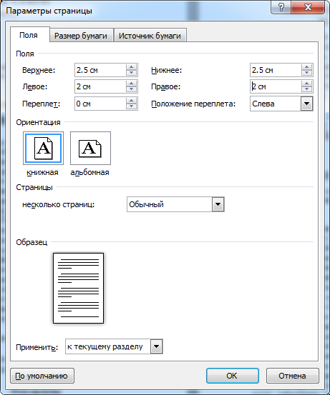
We ask you kindly do not number the pages!
The structure of the article:

The article heading is typed Times New Roman on the entire width of the sheet (in one column) in the following order:

Par. 1 - UDC (in the upper left corner of the page) - in the first line aligned to the left marginate (Times New Roman 12, semibold) interval before - 0 pt, after - 12 pt.

Par. 2 – the title of the article - with center alignment. Times New Roman - 14 pt., semibold, capital letters. The interval after - 12 pt.

Par. 3 - the list of (co) authors (preferably no more than 4 people) - surname and initials (Times New Roman 12, capital letters), the serial number on the list and, in addition to co-author for correspondence - an asterisk or number (superscript); scientific degree and academic rank (Times New Roman 12, italic).
Each new (co-) author is from a new line, with left-aligned. The interval before the block - 0 pt, after - 12 pt.

Par. 4 – the (co) authors information: footnote (superscript - arabic numeral and further asterisk for corresponding author) [if the authors two or more], the organization, where the author works, and / or department, the complete mailing address (building, house, street, locality, country), for the (co) author for correspondence - additional telephone numbers, fax, e-mail (required) website (if there is), ORCID unique number (you have the opportunity to register and receive an unique number in the register of researchers ORCID identifiers on https://orcid.org/register link).
Each additional address and data for the correspondence starts from a new line. Times New Roman 9. The interval before the block - 0 pt, after - 12 pt.

Par. 5 – the abstract (one paragraph, a volume of 250 to 300 words, no less than 20 lines) - with full justification, have to be structured (on the logic of the result descriptions in the article) and have to contain the following elements with their explicit identification of: purpose, methodology, results, scientific novelty, practical significance (semibold, italic). Times New Roman 9 pt. The summary do not have to repeat the title of the article. The first line - indent - 0.5 cm. The interval after - 12 pt.

Par. 6 - keywords (5-12 individual words and / or in a few phrases, in which can be a comma) - with full justification, Times New Roman 9 pt, simple, before the list is indicated in italics: keywords: separation mark - the semicolon, in the end of the list the point is not required. The interval after - 12 pt.

Paragraphs 2 ... 6 are given in English languages

The main text formatting of the article - in two columns with a gap of 0.7 cm.

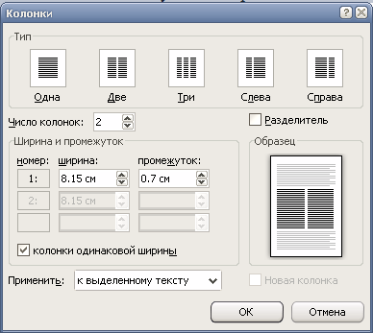

Do not number the pages!
The hyphenation mode - off!
The first line of all paragraphs is with the retreat of 0.5 cm, the same throughout the article. The all justification of paragraphs. Paragraphs are not separated from each other.
Times New Roman 10, line spacing – single.

.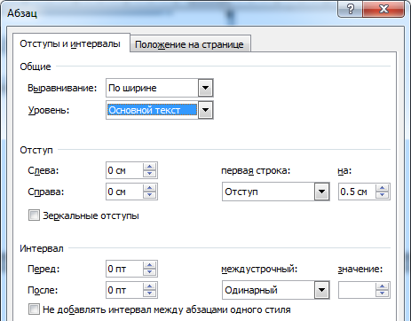

Hanging lines - the initial line of the paragraph, which is the last in the column, or the final line of the paragraph, which is the first in the column is not allowed.
.

The headlines elements of the main text are in semibold.
Headers are typed in Times New Roman, size 10 pt., semibold, in lowercase letters. There is not the first line indent, the center justification. From the previous text the subtitle is separated with an interval of 12 pt., from the subsequent - 6 pt.
There do not have to be letters and symbols from other fonts and size in the typed text. It is forbidden to replace any printed sign by another, formally similar.
It is not allowed, for example, replace the letter (O) to zero (0), the degree sign (°) to the divisional zero (0), the apostrophe (') to the inverted comma (‘), it can not also be the hard sign to replace with the apostrophe sign.
While the article typing it is necessary to distinguish "hyphen" (-), between "dash" (–).
The numbers, which indicate the boundaries of a quantity are divided with ellipsis, such as 20 ... 80 persons.
Applying: printing quotation marks («) [Alt 0171] and (») [Alt 0187], curly brackets (). If within the text enclosed quotation marks, are found individual words, also enclosed in quotation marks, for the entire passage must be applied "little fir trees" («...»), and for individual words inside - other quotation marks (" ").
In the initials after the point have to be a space, for example: I A Ivanov.
The number signe should be separated from the following for them number, in the plural sign is not doubled, for example: № 5, 6 and 7.
Signs of degrees, minutes, seconds (corner) can not be beaten from the previous numbers, for example: 10º, 10', 10".
Abbreviated dial designations should not be beaten from the degree sign, for example: 20 °C.
Percent signs are beaten from the previous number, for example: 10 %.
Table sets. Tables should give information to the reader in a clear and simple form, should be drawn concisely, clearly and should contain the minimum information, necessary to illustrate the text. In a well-designed table the header of each column is directly above it, and at the outset are indicators that define the data lines.
In the case of placing a table on several pages on its continuation / ending is specified respectively Continuation / Ending table 1. The heading of the table and the number of columns should be repeated on each page of the table.
There is allowed only in case of urgent need and in a limited number the deployed vertical tables (landscape) in the article.
The same nature tables should be made undifferentiated throughout the publication (fonts, lines, headers and columns, split between lines and so on).
The table should be placed as close as possible to the first reference in the text.
Tables are typed in Microsoft Word.
The desired length of the table is no more than one column of width - 8.15 cm or 17 cm The recommended size of the characters in the tables - 8-9 pt (for capacious tables is not less than 6 pt).
Table numbers: italic, Times New Roman, size 10 pt, right alignment, space before and after - 6 points.
The title of the table: Times New Roman, size 10 pt, semibold type, centered, space before - 0 points, after - 6 points.
The table title should be translated into English.
For example:
Table 1
Example of a table (width 8.15 cm)
Indicator 1 |  | Indicator 2
А | B | А | B
100 | 200 | 300 | 400

Figures (diagrams, pictures, etc.) are to be given in a color and black and white with the text in link places to them and sure in separate files (*.TIFF, *.jpg, etc.) with the licensing of 300 dpi. The quality of drawings and photographs should be the maximum. The desired width of drawings is 8.15 cm or more than 17 cm for maps, charts, and other bulk materials. The figure have to be located in the center, without text wrapping. Figures are placed "in the text" (not in the tables). Symbols, signature, drawing lines should be done in such way that its are perceived after reducing the size of the picture to the width of one column. Captions should include numbering in the stacking order in the text and explanatory caption, which are in italics. It is unacceptable to include a signature in the figure.
Illustrations should be prepared with the possibility of printing materials on rizografe, rather with a minimal use of gray shades (especially diagrams prepared in MS Excel).It is not allowed for illustration creating to use editing software built into Word for Windows !!!
The caption should be out of the picture, the intervals before and after - 6 pt, Times New Roman, italic, lowercase letters, font size 10 pt, centered. If after thematic headings of signature is given decoding then between them is placed the colon and the next posted decoding is typed in a smaller point size (9 pt.). The mandatory tranlating of the figure signature in English.
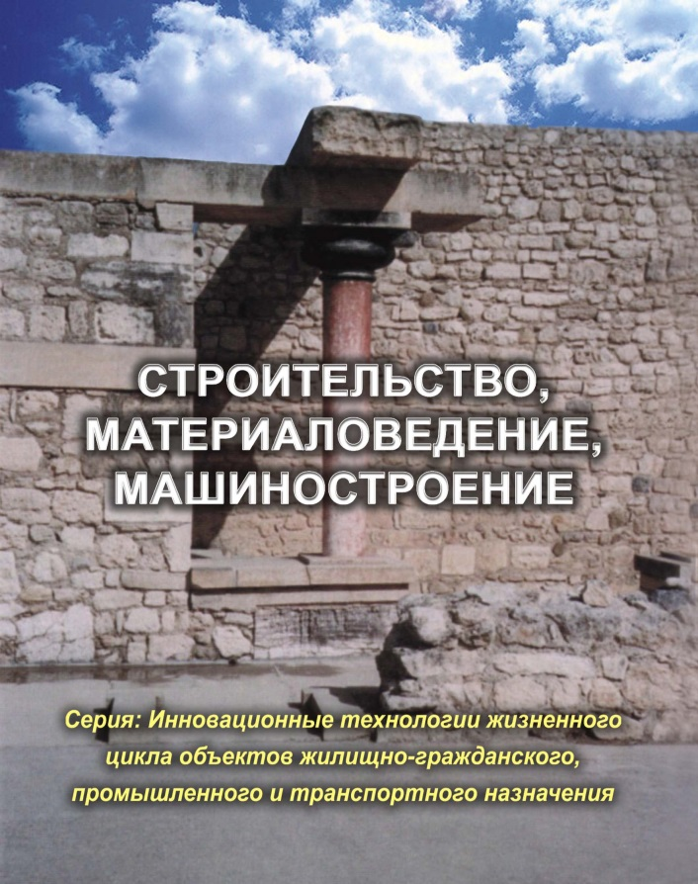

Fig. 1. Example of illustrations

Formula sets. For formula sets is used the built in Word for Windows formula editor Microsoft Equation 3.0 or MathType 5.
Formulas range the separate lines in the middle column and only simple, small formulas, which do not have independent sense are positioned within text strings.
Arabic numerals in parentheses denote a formula number of the article. It is placed at the right edge of the dial in one line with the numbered formula. If it is a multiline formula, a number is placed in line with the last line of the formula.
Formulas are arranged so, that its are placed in a column of 81.5 mm in width. Before and after of formulas is an interval of 6 pt.

Common set of rules:
1. The numbers in the formulas are typed in a upright font.
2. Literal marking of values (symbols), which use letters of the alphabet are typed in italics.
3. The reduced mathematical terms (for example, sin, arcsin, lg, lim, const, max) are typed in a upright font.
4. Abbreviations of physical and technical units, metric measures and their derivatives are typed in a upright font without points, for example: 10 V, 25 kW, 12 km.
5. Reductions in the indexes is typed in a upright font, for example: L_{pol} (L pol.). If the index is a value symbol, it is printed in italics, for example: p - pressure; x - coordinate; i, k - the current indexes.
6. It is not permitted to place designation unit next to the formula that shows the dependence between values or between their numerical values in the form of letters.
Parameters of the formula editor:

REFERENCES is given below the main text of the article, after the "Break section (on the current page)." Its are performed in a single column on the page width. The references in the text are placed in square brackets ([1]). The reference list is made in the following order: first, all references in the Cyrillic alphabet from A to Z, then all the Latin alphabet (A ... Z), presented in alphabetical order. Then this list is numbered consecutively in Arabic numerals.
Each reference record is according to "State Standard 7.1:2006. The standards system on information, librarianship and publishing. The bibliographic record. The bibliographic description. General requirements and rules", which is valid from 01.07.2007.
The transliteration of authors' names is performed, depending on the language of the original source as required by the Decree of the Cabinet of Ministers of Ukraine dated on January 27, 2010 №55 "About harmonization of translіteration of Ukrainian alphabet in Latin" (for the Ukrainian language), or the requirements of BGN / HCGN system (for the Russian language).

Separately, the REFERENCES are done, according to the Harvard style, that does not have stringent canonical requirements for the composition and have a conventional recommender character. Each university chooses for itself. Thus, REFERENCES in journals of different universities have basically a similar design, but the details may differ greatly!

REFERENCES for "Construction, Materials Science, Mechanical Engineering", "Physical Metallurgy and Heat Treatment of Metals" and "Prydniprovij Engineering Science of News" are made as follows:

There is the tranlating of authors (initials are placed on the right, between the point of the name letter and surname letter the space is not put [Shparber M.E.,]), surname and initials are written in transliteration in the beginning. If there are no authors, it is indificated an editor. If there is more than one author before the last author instead of "," is written the word "end". After the last author and his initials is set ".", are written the transliterated name of the article, journals, books (in the general reference) in italics. After that is set the space and is opened the "[]". There is written the translation of the book names in English. After square brackets are put a point and ".". Then there is all that is behind "//". It is recorded a transliterated title (in italics) in the "[]" and the English translation, is placed in the ".". Then (for the book) city ":" publishing "," year "," the number of pages «p.». (Kyiv: Vyd-vo Yevropeiskyi Universytet, 2008, 208 p.) The transliteration record is without italics.
For articles: italic and transliterated name of the journal, the collection, in the "[]" the English translation, at the end of ".". Then the abbreviation of the organization (if there is some) "," city "," vol "," iss "," № "," the pp '. " the range of the pages ".'. The record is transliterated without italics. After "." in the end in "()" is written the original language of the article. (Stroitelstvo, materialovedenie, mashinostroenie - [Construction, materials science, mechanical engineering]. PDABA Dnipropetrovsk, 2013, no. 69, pp. 242-246. (in Ukrainian).)
There are four types of dash: dash (long) «—»; short (average) dash «–», minus; «–» and dash «-».
In all cases, we apply a short (average) dash «–»!
The References are supplied in original language (examples of both literature lists see in attachment 1).

Requirements to the list of links:
- Volume is at least six sources (not more than 13, in rare cases up to 20);
- Not less than 3 Latin sources to the foreign journal with a high index of influence or the basic monograph in this field;
- The most of references (including the original foreign references) must be no more than 8-10 years;
- The mandatory translating of references in English. In the list of references, each Ukrainian- or Russian-speaking must be shown first in the original language and then be translated in English.
- The mandatory internet link to the website, where it can be get acquainted with the reference;
no more than 20% self citations to each of the co-authors.
The references list is supplied in alphabetical order, references in Latin at the end of the list and is presented subtitled REFERENCES – TNR 10 pt, italic), which is separated from the main text and from the reference list with intervals before 12 pt., after 6 pt. and is located in the middle of the column.
The reference list of articles is supplied in Times New Roman 9, numbered, with first line indented - 0.5 cm.
Abbreviations in the bibliographic description is carried in accordance with the State Standard 3582: 2013 out. The city's name is not reduced.

The references in the article are obligatory!
Then through the line are specified recommendations to the publication of the article - a scientific degree, rank and name, (country) of reviewer. The font - TNR 9 pt, italic.

The date of the manuscript receipt to the editorial board is placed under the bibliography indicate with arabic numerals: two digits for the day, month and four - for the year. The font - TNR 10 pt.

WITH THE ARTICLE TO THE EDITOR ARE SUPPLIED:

- The information about the authors in print and electronic form: first name, name and patronymic in full, academic degree, academic status, place of work (full and abbreviated name of the organization), position, city, country, contact phone numbers and e-mail (formatting on the entire page, data entry through commas) are supplied in a separate file in Ukrainian, Russian and English.
- Reviews for printing two doctors of science (mandatory for students, graduate students, PhD)
- The extended summary in English - at least 2 pages, performed by the same requirements as the main text of the article. (on the performance of the Order №1111 from 11.10.2012, "About approval of the procedure of the list formation of scientific specialized publications of Ukraine" in the publication of articles in the scientific collection is necessarily its presentation in English on the publisher's website). The text of the article in English should be proofread and checked by the authors.

The responsibility for the article content, correctness, accuracy and correctness of the citation, references, and translation have the authors.
The responsibility for the article contents have the author. Submissions will not be returned.
Articles that do not meet the requirements of the editorial board of the scientific collection "Construction. Materials. Mechanical engineering" are not considered.

At the author request the library of “Prydnipprovs’ka State Academy of Construction and Architecture” offers the following paid services - http://library.pgasa.dp.ua/index.php/en/platnyye-uslugi

Attachment 1 (exaple of references)

references
- Derghavna slughba statystyky Ukrainy. Vvedennia v ekspluatatsiiu zhytlovykh budynkiv [Commissioning of residential buildings]. Derghavna slughba statystyky Ukrainy. Statystychna informatsiia. Naselennia ta ghytlo. [State department of statistic of Ukraine. Statistic information. Population and housing]. Available at: http://www.ukrstat.gov.ua. (in Ukrainian).
- Minregion Ukrainy. Vyznachennia klasu naslidkiv (vidpovidalnosti) ta kategorii skladnosti obiektiv budivnytstva: DCTU N B V.1.2-16:2013 [State standard of Ukraine N B V.1.2-16:2013.The definition of the class of consequences (responsibility) and category of complexity for construction objects]. Kyiv, 2013, 37 p. Available at: http://www.dbn.at.ua. (in Ukrainian).
- Yesypenko A.D. Pryntsypy formuvannia systemy utrymannia ta remontu budynkiv, sporud ta inzhenernykh merezh [Principles of formation of system of maintenance and repair of buildings, structures and engineering networks]. Budivnytstvo Ukrainy [Construction of Ukraine]. 2006, no. 1, pp. 36-38. (in Ukrainian).
- Derghavna slughba statystyky Ukrainy. Zhytlovyi fond Ukrainy [The housing fund of Ukraine]. ]. Derghavna slughba statystyky Ukrainy Statystychna informatsiia. Naselennia ta ghytlo. [State department of statistic of Ukraine. Statistic information. Population and housing]. Available at: http://www.ukrstat.gov.ua. (in Ukrainian).
- Ushats'ky S.A., Pokolenko V.O., Tuhay O.A., Lahutin H.V., Borysova N.O. and Rubtsova O.S. Innovatsiini kontseptualni ta formalno-analitychni instrumenty obgruntuvannia, pidgotovky ta vprovadzhennia budivelnykh investytsiinykh proektiv [Innovative conceptual and formal analytical tools substantiation, preparation and implementation of construction investment projects]. Kyiv: Vyd-vo Yevropeiskyi Universytet, 2008, 208 p.
- Poisk nedvighimosti. Kiev [ Search real estate. Kiev]. Assotsiatsiia spetsialistov po nedvigimosti (rieltorov) Ukrainy. Real estate. [Association of specialists of real estate of Ukraine. Real estate]. Available at: http://www.asnu.net
- Kievskiy I.L. Vliyanie organizatsionno-tekhnologicheskikh faktorov na realizatsiyu produktsii zhilishchnogo stroitelstva. Avtoreferat kand. [The impact of organizational and technical factors on sales of products of housing construction. Abstract of Ph. D. dissertation]. Tsentral. nauch.-issled. i proektno-eksperiment. in-t org., mekhanizatsii i tekhn. pomoschi str-vu. Moscow, 2003, 22 p. (in Russian).
- Kravchunovska T.S. Kompleksna rekonsruktsiia zhytlovoi zabudovy: organizatsiino-tekhnologichni aspekty [Complex reconstruction of residential development: organizational and technological aspects]. Dnipropetrovsk: Nauka i osvita, 2010, 230 p. (in Ukrainian).
- Kravchunovska T.S., Bronevytskyi S.P., Mykhailova I.O. and Martens O.O. Problemy i perspektyvy budivnytstva dostupnogo zhytla v Ukraini [Problems and prospects of affordable housing in Ukraine]. Stroitelstvo, materialovedenie, mashinostroenie – [Сonstruction, materials science, mechanical engineering]. PDABA. Dnipropetrovsk, 2013, no. 69, pp. 242-246. (in Ukrainian).
- Kirnos V.M., Andreev V.G., Uvarov E.P., Tseloval'nikov V.A., Rudenko N.N., Uvarov P.E., Punagin V.N., Shparber M.E., Damaskin B.S., Pilipenko V.M., Pashkov A.P., Kravchunovskaya T.S., Galich E.G., Yugov A.M., Kozhemyaka S.V., Savjovskij V.V. and Kotlyar N.I. Kontseptualnye osnovy regionalnoy politiki razvitiya kompleksnoy rekonstruktsii obyektov zhiloy nedvizhimosti s maksimalnym ispolzovaniem sushchestvuyushchikh zdaniy i infrastruktury gorodskikh territoriy [Conceptual foundations of regional policy for the development of complex reconstruction of residential properties with maximum use of existing buildings and infrastructure of urban areas]. Dnipropetrovsk: Nauka i osvita, 2010, 121 p. (in Russian).
- Kostetskiy N.F. and Gurko A.I. Zarubezhnyy opyt gosudarstvennogo regulirovaniya vosproizvodstva zhilishchnogo fonda, yego sokhraneniya i modernizatsii [Foreign experience of state regulation of reproduction of housing, preservation and modernization]. Ekonomika stroitelstva [Construction Economics]. 2003, no. 1, pp. 13-30. (in Russian).
- Ositnianko A.P. Planuvannia rozvytku mista [City development planning]. Kyiv: KNUCEA, 2001, 460p. (in Ukrainian).
- Tian R.B., Uvarov P.Ye., Ivanov S.V. and. Prylyepova M.O. Systemy tekhnologii zhyttievogo tsyklu investytsiino-budivelnoi sfery diialnosti [Technology life cycle of investment and construction sector activity]. Dnipropetrovsk: Vyd-vo Makovetskyi Yu.V., 2010, 344 p. (in Ukraininan).
- Shutenko L.N. Tekhnologicheskie osnovy formirovaniya i optimizatsii zhiznennogo tsikla gorodskogo zhilogo fonda (teoriya, praktika, perspektivy) [Technological bases of formation and optimization of the life cycle of the urban housing fund (theory, practice, prospects)]. Kharkov: Maydan., 2002, 1053 p. (in Ukrainian).
- Richard L. and Eschemuller J. Urban construction project management. New York: McGraw-Hill, 2008, 480 p.
- Economic commission for Europe and United Nations. Spatial planning. Key instrument for development and effective governance with special reference to countries in transition. New York; Geneva, 2008, 46 p. Available at: http://www.unece.org/fileadmin/DAM/hlm/documents/Publications/spatial_planning.e.pdf.
- Sarka V., Zavadskas E.K., Ustinovicius L., Sarkiene E. and Ignatavicius C. System of project multicriteria decision synthesis in construction. Technological and economic development of economy. 2008, vol. 14, no. 4, pp. 546-565.
- Sidney V. Levy. Project management in construction. New York: McGraw-Hill, 2006, 402 p.
- Ositnianko A.P. Planuvannia rozvytku mista [City development planning]. Kyiv: KNUCEA, 2001, 460 p. (in Ukrainian).
- Tian R.B., Uvarov P.Ye., Ivanov S.V. and. Prylyepova M.O. Systemy tekhnologii zhyttievogo tsyklu investytsiino-budivelnoi sfery diialnosti [Technology life cycle of investment and construction sector activity]. Dnipropetrovsk: Vyd-vo Makovetskyi Yu.V., 2010, 344 p. (in Ukraininan).

